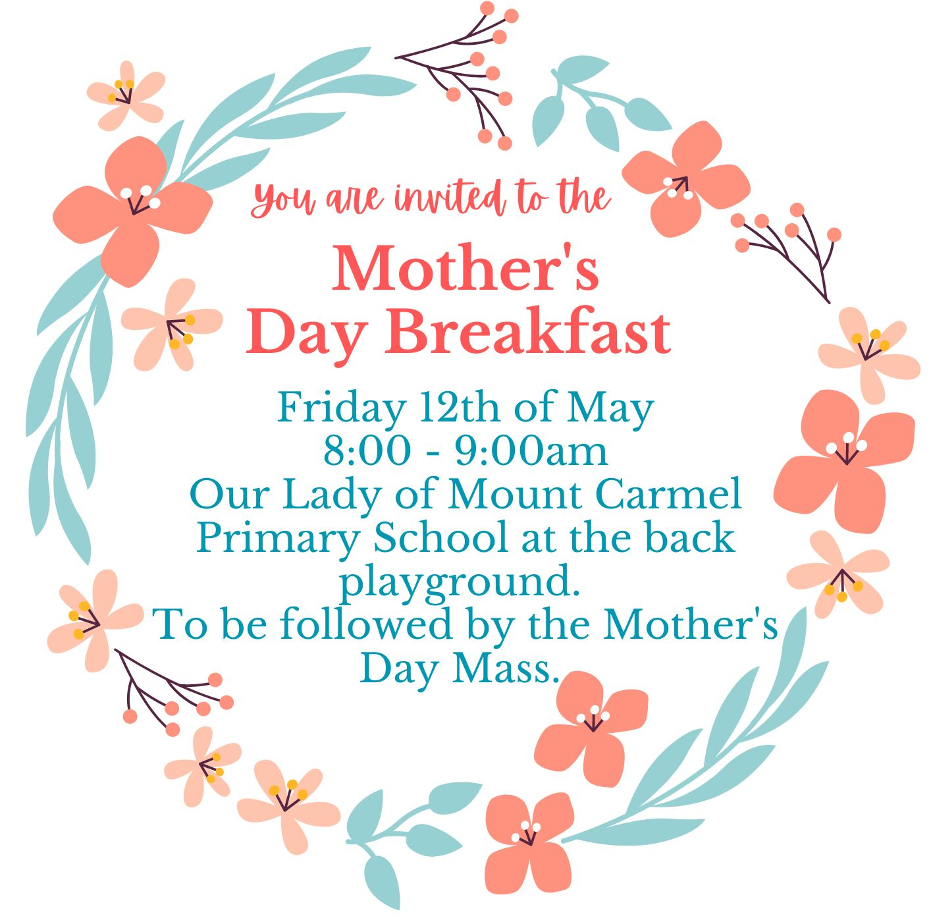
----------------------------------------------------------------------------------------

Mother’s Day Breakfast and Mass 2023

Please return this slip to your child's teacher.

- I will be attending the Mother's Day Breakfast. No. attending _____

- I will be attending the Mother’s Day Mass. No. attending ______

Eldest Child’s Name: ________________________ Class: _______

